**03-09-2025**

**CONDITIONAL FORMATTING:**

**1.**

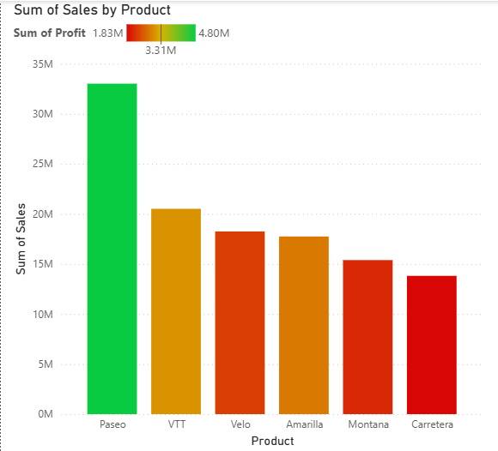

STEPS:

* When we have to represent two measures in one chart we use this conditional formatting.
* In this case I wanted to represent both product wise profit and product wise sales in the same chart so conditional formatting helps.
* In Visualization pane, select the column chart and populate it with product in x-axis and sales in y-axis.
* Go inside format visual pane and select columns inside it we find color option beside is the conditional formatting option with “fx” on the button.
* Click on conditional formatting and a dialog box appears as below.

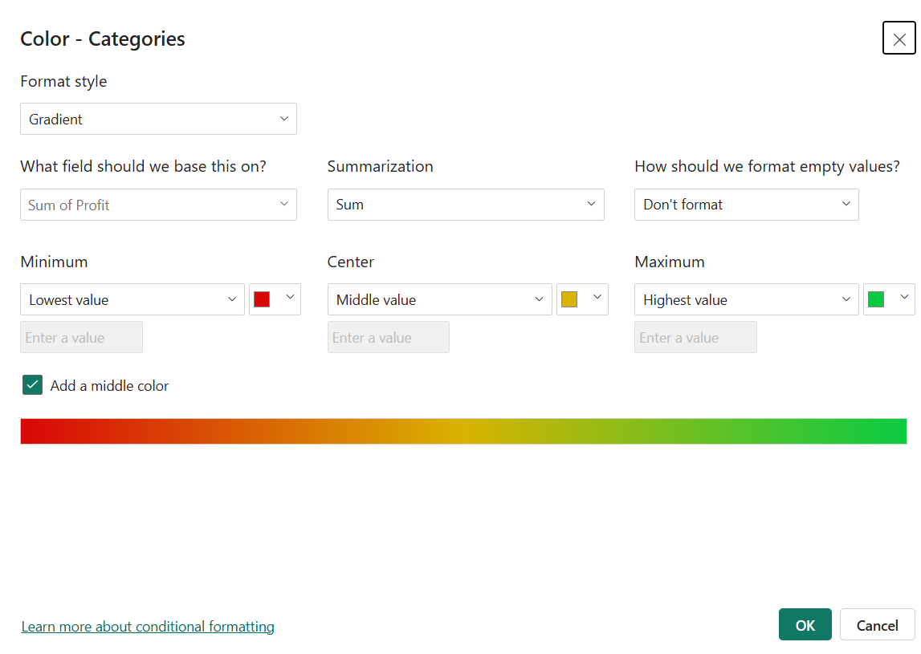

* Select the format style to Gradient, select the field to base on as profit and don’t format empty values, select different color gradients for minimum, maximum and middle values, click on OK.
* We can see the interpretation in the chart plotted in order of sales and colored in order of profit.

2.

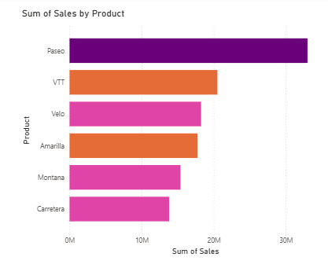

STEPS:

* In this case I wanted to represent both product wise profit and product wise sales in the same chart so conditional formatting helps.
* In Visualization pane, select the column chart and populate it with product in x-axis and sales in y-axis.
* Go inside format visual pane and select columns inside it we find color option beside is the conditional formatting option with “fx” on the button.
* Click on conditional formatting and a dialog box appears as below.

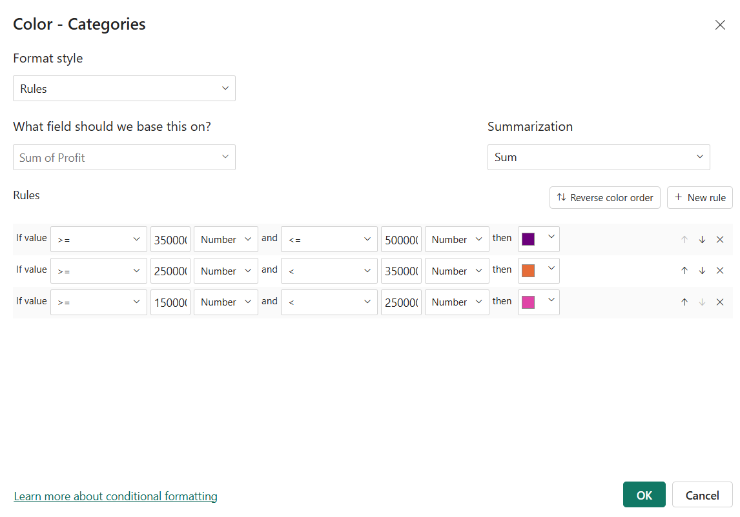

* In the Format style select Rules and field to base on as profit, then you can give the rules and for every rule give different color. Press OK.
* We can see the interpretation of conditional formatting in the chart.
* The products are ordered as per sales and colored based on profit range.

3.**FILTERS**

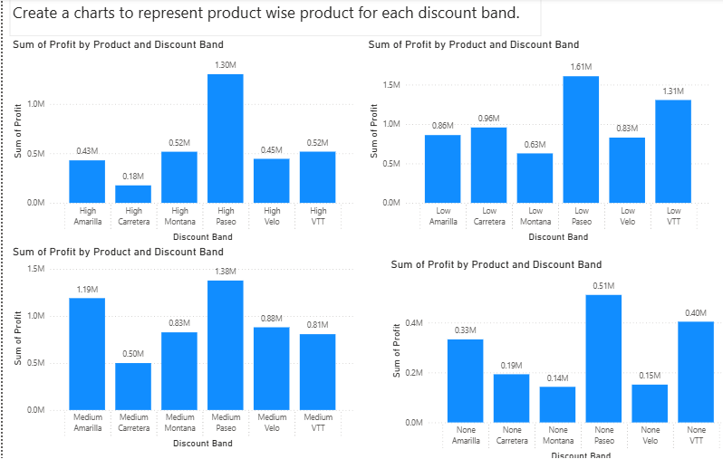

STEPS:

* In the question we are asked to represent the product wise profit for each of the discount band separately.
* To represent more than two values in a chart we use filter, Filters are totally used by developers and can’t be used by users.
* To do so we are using Filters, first start by creating a chart with product in x-axis and profit in y-axis.
* Drag and drop the discount band in the x-axis now we can see the product wise profit divided by discount bands.
* Now go to filters pane and navigate to discount band section and select one discount band.
* Replicate the chart for three more times and select different band for each chart.
* Turn on the data labels and there we go with the product wise profit for each discount bands.

**4.SMALL MULTIPLES**

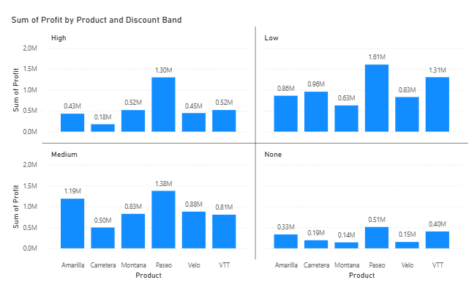

STEPS:

* For the same above question instead of creating four different charts manually we can create all at once using small multiples.
* Start selecting the visual from build visual pane and drag and drop products to x-axis, profit to y-axis and profit to the small multiples’ fields.
* Automatically the chart like above gets created as easy, time saving and effective.

**Basic Introduction Questions on Power BI**

1. What is Power BI?

Power BI is a business analytics tool from Microsoft that helps people visualize, analyse and share data transforming raw numbers into interactive charts, dashboards, and reports that are easy to explore and understand. It empowers users to make smarter business decisions by uncovering insights hidden in their data.

2. Who developed Power BI?

Power BI was developed by Microsoft, one of the world’s leading technology companies. Its development began within Microsoft’s SQL Server team, and it became publicly available in 2015.

3. Why do we use Power BI?

We use Power BI to turn complicated data into meaningful, actionable visuals and insights. It enables anyone from analysts to executives to explore trends, monitor business health, and share findings through interactive dashboards, making decision-making easier and more data-driven.

4. What are the main components of Power BI?

Power BI consists of several key components that work together:

* Power BI Desktop: A Windows program for building reports and data models.
* Power BI Service: A cloud-based platform for sharing, viewing, and collaborating on data reports online.
* Power BI Mobile: Apps for smartphones and tablets that let users interact with reports and dashboards on the go.
* Power Query & Power Pivot: Tools for connecting to, transforming, and modelling data.
* Visualizations/Dashboards: The interactive charts and data tiles that users create and share.

5. What is Power BI Desktop?

Power BI Desktop is a free Windows application where users create and develop data reports and dashboards. It allows connection to data sources, designing visuals, modelling data, and building powerful interactive reports on a personal computer before publishing them to the cloud.

6. What is Power BI Service?

Power BI Service is Microsoft’s cloud-based platform for Power BI. Users upload, view, and share reports and dashboards, set up automatic data refresh, and collaborate securely within organizations all through their web browser.

7. What is Power BI Mobile?

Power BI Mobile refers to the mobile apps available on iOS and Android devices. These apps let users view, interact with, and share dashboards and reports from anywhere, enabling on-the-go access to important business data insights.

8. What is the difference between Power BI Desktop and Power BI Service?

* Power BI Desktop is mainly for building and editing reports locally on a computer. It offers advanced data modelling and design features.
* Power BI Service is web-based, used for sharing, collaborating, and viewing reports and dashboards after publishing them from the desktop. It focuses on team collaboration, refreshing data, and distributing insights.

9. What are the key features of Power BI?

Some of the most powerful features include:

* Connects to many data sources (databases, Excel, cloud storage, web APIs, etc.).
* Interactive visualizations like graphs, maps, charts, and dashboards.
* Custom visual creation and data modelling tools.
* Real-time data monitoring and automatic refresh.
* Collaboration and sharing capabilities in the cloud.
* Mobile access to reports and dashboards.

10. What types of data sources can Power BI connect to?

Power BI can connect to a vast array of sources, such as:

* Excel spreadsheets and CSV files.
* Databases (SQL Server, Oracle, MySQL, PostgreSQL, etc.).
* Cloud services (Azure, Google Analytics, Salesforce, etc.).
* Web APIs and many more.

11. What is a visualization in Power BI?

A visualization in Power BI is any type of graphical display of data, such as bar charts, line graphs, pie charts, maps, or even custom visuals. Visualizations help translate complex data into easy-to-understand graphics, making patterns, trends, and anomalies clear for better business insights. Each tile, chart, or visual displayed in a Power BI report or dashboard is considered a visualization.